

software design document for fym

Version 0.4



June 20, 2018

amaal asaad ibrahem

Mona Mohamed Abdelmohsen

Mariam Mohamed Bader Eldin

Menna allah hesham

Aya Shaban Mahmoud

**TABLE OF CONTENTS**

*1. INTRODUCTION ….........................................................................*

*1.1 Purpose ….........................................................................*

*1.2 Scope ….........................................................................*

*1.3 Reference Material ….........................................................................*

*1.4 Definitions and Acronyms …..............................................................*

*2. SYSTEM OVERVIEW ….........................................................................*

*2.1 System Function …………………………………………………………………………….*

*2.2 Context diagram …………………………………………………………………………….*

*2.3 project design …...................................................................................*

*3. SYSTEM ARCHITECTURE ….........................................................................*

*3.1 Architectural Design ….....................................................................*

*3.2 Flow Chart ….......................................................................................*

*3.3 Decomposition Description ….........................................................*

*3.3.1 subsystems in the architectural design. ….....................................*

**1***)The architectural design for web application FYM phase. …....*

***Presentation layer*** *….....................................*

***Logic tier*** *….........................................*

***Data access tier*** *…...............................*

**2***)The architectural design face recognize phase. ….........*

***About algorithm*** *…................................................*

***Pre-processing*** *…................................................*

***Implementation phases*** *…....................................*

*3.3.2 Top level data flow diagram (DFD) ….......................................*

*Context diagram …...................................................................*

*Level 0 diagram….........................................................................*

*Level 1 diagram ….......................................................................*

*3.4 Design Rationale ….........................................................................*

*In web application phase…................................................................*

*In face recognize phase …....................................................................*

*4. DATA DESIGN …..........................................................................................*

*4.1 Data Dictionary …...............................................................................*

*5. HUMAN INTERFACE DESIGN ….................................................................*

*5.1 Overview of User Interface …...............................................................*

*5.2 Screen Images …..................................................................................*

*5.3 Screen Objects and Actions …...............................................................*

*6. APPENDICES …..............................................................................................*

**1. INTRODUCTION**

**1.1 Purpose**

* This document contains the complete design description of the *find Your Missing (FYM)*.
* This includes the architectural features of the system down through details of what operations each code module will perform and the database layout.
* It also shows how the use cases detailed in the SRS will be implemented in the system using this design.

* and provide an overview for implementation. Its main purpose is to - • Provide the link between the Functional Specification and the detailed Technical Design documents • Detail the functionality which will be provided by each component or group of components and show how the various components interact in the design • Provide a basis for My Doctor’s detailed design and development

**1.2 Scope**

* FYM system is a website that aims to help its users by achieving the following:
* find their missing relatives using Face Recognition Technology.
* The Application Design outlined in this document builds upon the scope

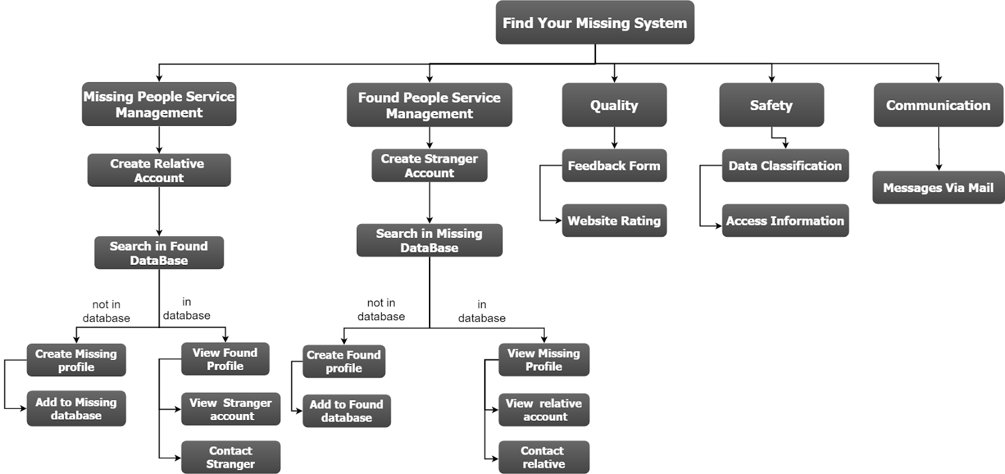

**1.3 Reference Material**

Team members, *find your missing web, Software Requirements Specification for FYM software*.

<https://en.wikipedia.org/wiki/Data_dictionary>

<https://www.geeksforgeeks.org/data-access-object-pattern/>

<https://www.geeksforgeeks.org/front-controller-design-pattern/>

<https://docs.google.com/document/d/1J3rrlbiQ0rwJLu_GWmptFW-vD1EamYtuHBhuhapFeOc/edit#heading=h.z6ne0og04bp5>

<http://portal.unimap.edu.my/portal/page/portal30/Lecturer%20Notes/KEJURUTERAAN_KOMPUTER/Semester%202%20Sidang%20Akademik%2020112012/EKT420%20Software%20Engineering/Example%20of%20Software%20Design%20Document(SDD)>

<http://www.robots.ox.ac.uk/~vgg/>

**1.4 Definitions and Acronyms**

* FYM: Find Your Missing System
* Relative ID: Relative Identification Card Number
* FaceNet : Unified Embedding for Face Recognition and Clustering.

**2. SYSTEM OVERVIEW**

2.1 System Function

1. Register
2. Log in
3. Add missing profile
4. View missing profiles
5. View missing profile details
6. Add found profile
7. View found profiles
8. View found profile details
9. Log out

2.2 Context diagram

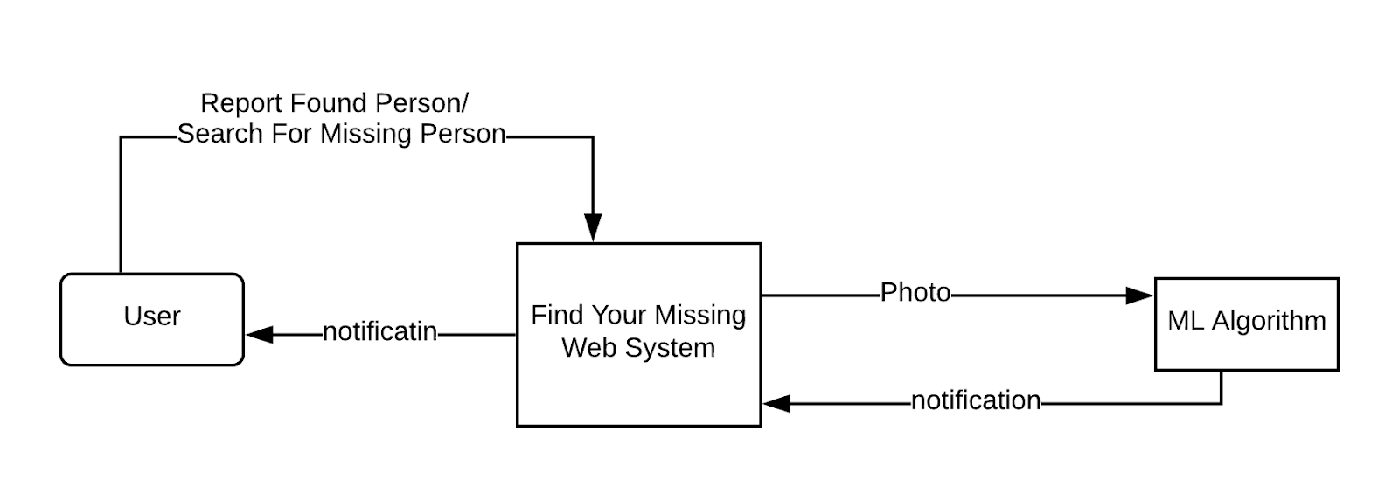

2.3 project design

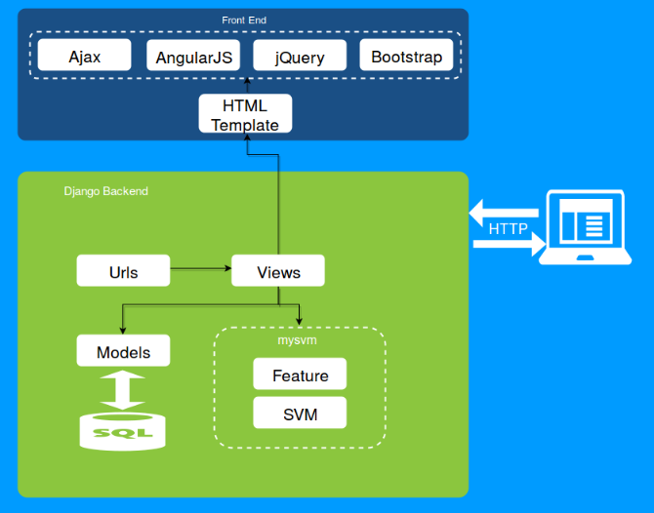

**3. SYSTEM ARCHITECTURE**

3.1 Architectural Design

There are two parts of this system:

* The FYM web application using 3-tier architecture with a database on the server.
* The face recognize is a architecture using a database.

3.2 Flow Chart

Tow systems interface with each other in this sequence:

The browser will send HTTP request as GET or POST from our Web FYM.

* GET request can be for loading templates which is an html file or for a static file, which includes front end JavaScript files (js), stylesheets (css), true type fonts(ttf) and image files.
* User upload the image by a HTTP POST. Our back-end interface will grab the given image, After a successful POST, user can send a GET request for view the found and missing images.

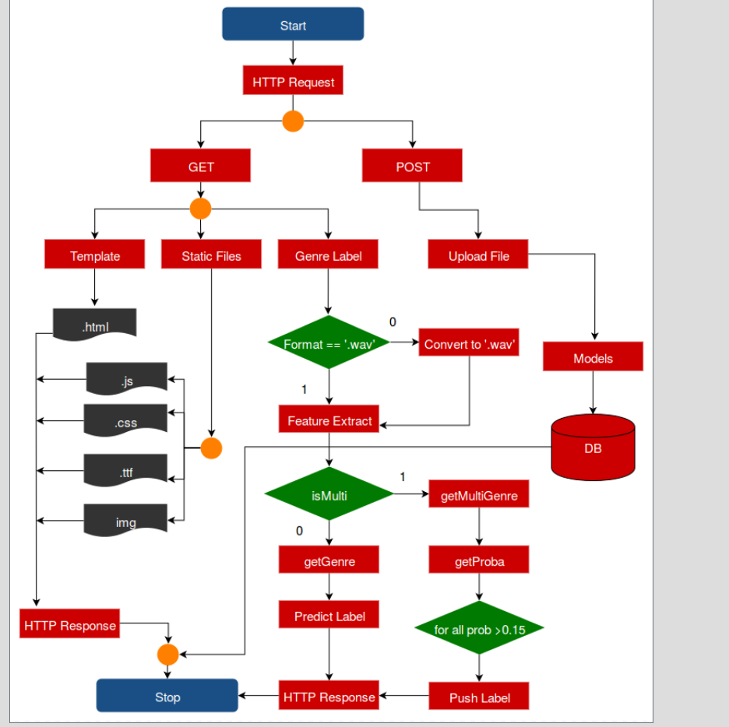

3.3 Decomposition Description

3.3.1 subsystems in the architectural design.

* **1)The architectural design for web application FYM phase.**
* The 3-tier architecture consists of three layers:

presentation tier, logic tier, and data tier.

***Presentation tier*** is the highest layer in the architecture which deals with the graphical user interface of the application***. Logic tier*** is the middle tier which connects the highest and lowest layer together.

***Logic tier*** is represented by the functions which takes inputs from the user and deliver it to do some computation and arithmetic operations in the database. Logic tier consists of business logic and data access logic. Business logic deals with the presentation tier.

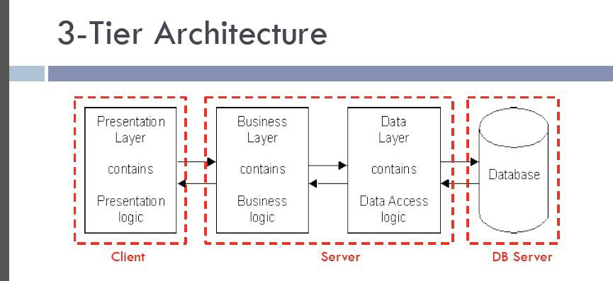

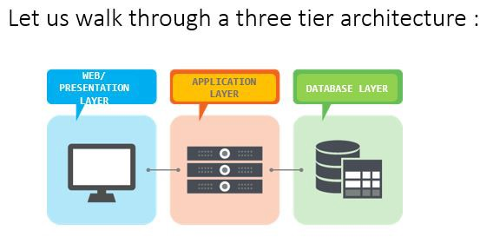

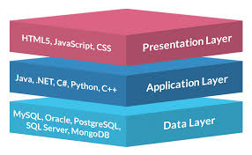 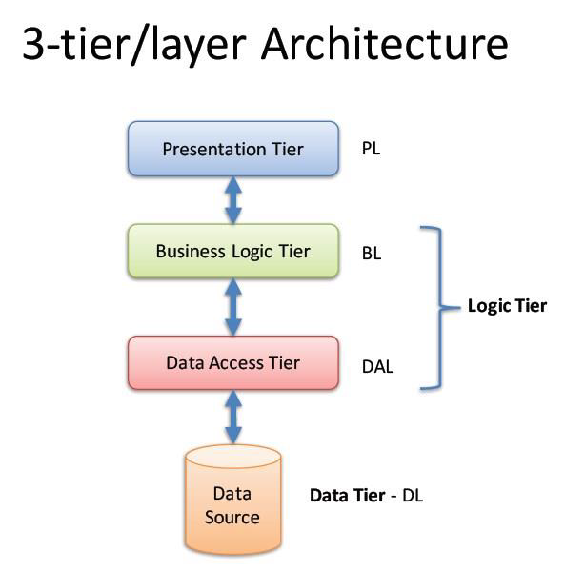

* Presentation Layer

A standard Internet Browser such as chrome is the primary client for the online web application.

HTML pages are delivered to the client browser by the web application upon a user request.

The Web Pages also include JavaScript functions where applicable. If JavaScript is turned-off, server-side validations are performed to ensure all validations are met.

**The design pattern** which is used is front controller design pattern:

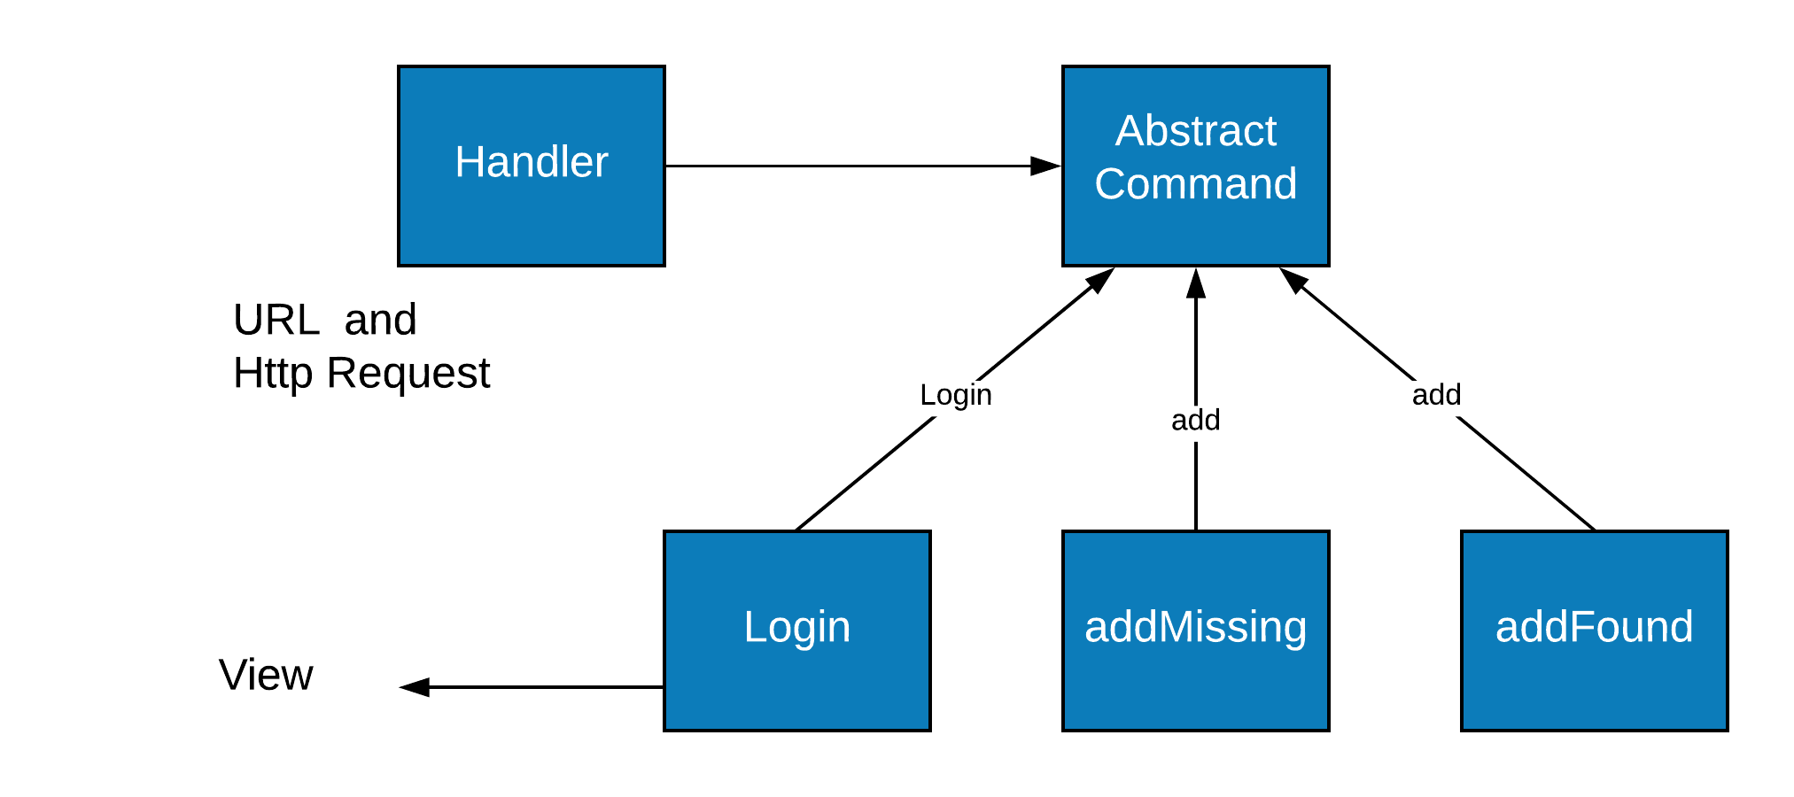

The front controller design pattern means that all requests that come for a resource in an application will be handled by a single handler and then dispatched to the appropriate handler for that type of request. The front controller may use other helpers to achieve the dispatching mechanism.

* **Controller:** The controller is the initial contact point for handling all requests in the system. The controller may delegate to a helper to complete authentication and authorization of a user or to initiate contact retrieval.
* **View:**A view represents and displays information to the client. The view retrieves information from a model. Helpers support views by encapsulating and adapting the underlying data model for use in the display.
* **Dispatcher:** A dispatcher is responsible for view management and navigation, managing the choice of the next view to present to the user, and providing the mechanism for vectoring control to this resource.
* **Helper:** A helper is responsible for helping a view or controller complete its processing. Thus, helpers have numerous responsibilities, including gathering data required by the view and storing this intermediate model, in which case the helper is sometimes referred to as a value bean.

***Advantages:***

* **Centralized control:**Front controller handles all the requests to the Web application. This implementation of centralized control that avoids using multiple controllers is desirable for enforcing application-wide policies such as users tracking and security.
* **Thread-safety:** A new command object arises when receiving a new request and the command objects are not meant to be thread safe. Thus, it will be safe in the command classes. Though safety is not guaranteed when threading issues are gathered, codes that act with command is still thread safe.
* logic tier

*(business)add profile layer*

it will implement add profile rules for the application.

It will host the add profile service components as well as image objects (IO).

*The design pattern* which is used in this layer is session façade design pattern



The Façade pattern helps to encapsulate the complexity of interactions between the image objects participating in a workflow.

It manages the image objects, and provides a uniform coarse-grained service access layer to clients, that expose only the required interfaces.

* **Data access tier**

Data Access Objects using ***SQLite3*** database will manage the interface to the database.

Component needs to be aware of this complexity.

Moreover, there are many forms of storage from databases, to flat files. Decoupling the persistence logic from the business components and client allows for a flexible, easy to maintain application. The Data Access Object (DAO) pattern allows for the abstraction of the persistence from the business component. The Data Access Object manages the connection to the data source to obtain and store data. It encapsulates all access to the data store.

***The design pattern*** which is used in this layer is data access object pattern.

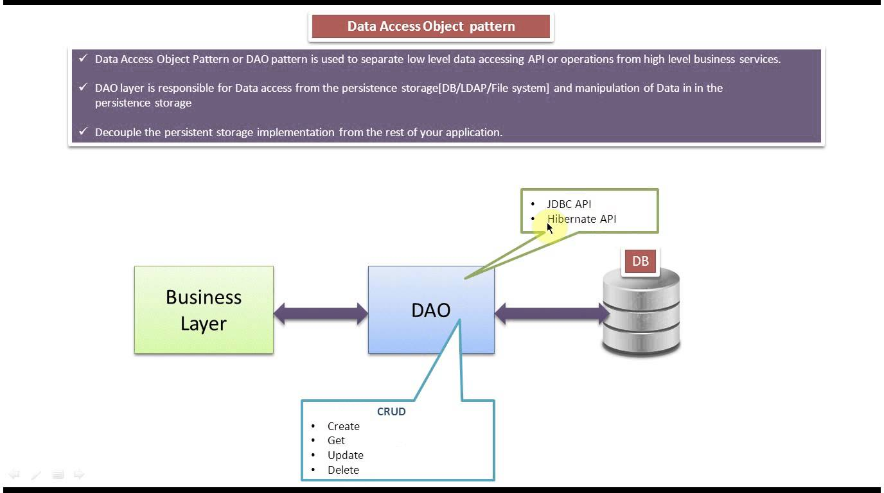

**Class diagram:**

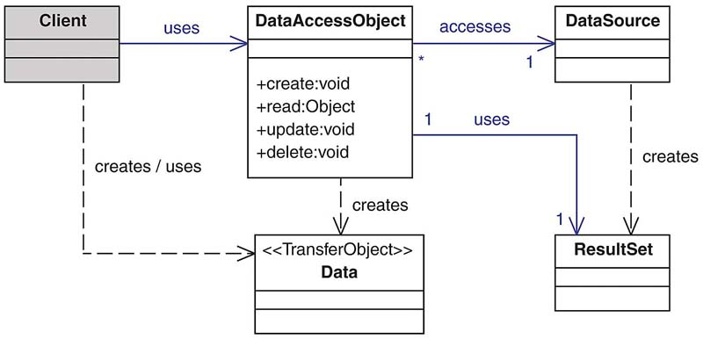

* **The architectural design for face recognize phase.**

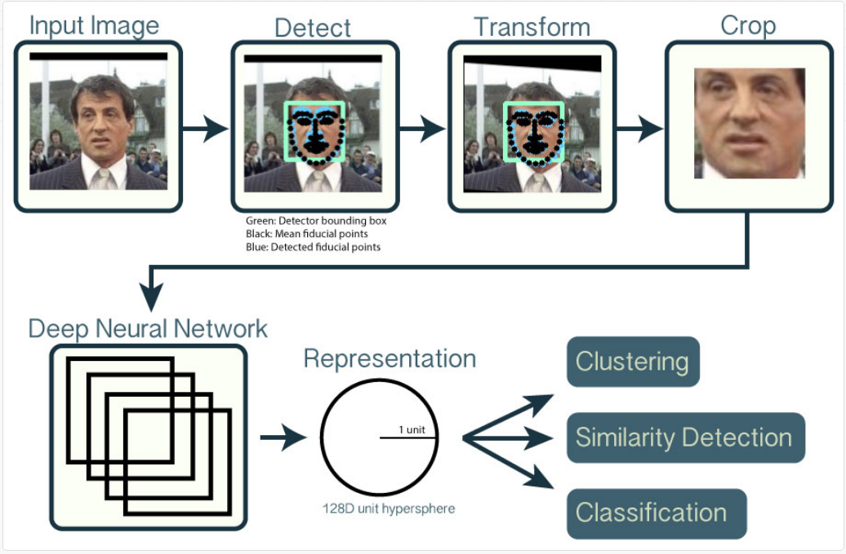

* **About algorithm:**

***The simplest approach*** to face recognition is to directly compare the unknown face we found in Step 2 with all the pictures we have of people that have already been tagged. When we find a previously tagged face that looks very similar to our unknown face, it must be the same person.

***The real advanced approach*** extracts a few basic measurements from each face. Then we could measure our unknown face the same way and find the known face with the closest measurements.

**Tesorflow** model is usedin Implementation of face recognize.

**FaceNet:**

* A Unified Embedding for Face Recognition and Clustering

that directly learns a mapping from face images to a compact Euclidean space where distances directly correspond to a measure of face similarity.

* Once this space has been produced, tasks such as face recognition, verification and clustering
* can be easily implemented using standard techniques with FaceNet embeddings as feature vectors.
* deep convolutional network trained to directly optimize the embedding itself.
* To train, we use triplets of roughly aligned matching / non-matching face patches generated using a novel online triplet mining method..
* On the widely used Labeled Faces in the Wild (LFW) dataset.
  + We also introduce the concept of harmonic embeddings, and a harmonic triplet loss, which describe different versions of face embeddings (produced by different networks)
  + train a model using softmax loss on the CASIA-WebFace dataset.

## Pre-processing

### Face alignment using MTCNN

* Using face landmark detectors Multi-task CNN.

used A Matlab/Caffe implementation for face alignment with very good results.

* **Implementation phases:**

#### Step1: (face detection)

#### Finding all the Faces in image.

#### Step 2: Posing and Projecting Faces

* To do this, we are going to use an algorithm called face landmark estimation is Multi-task CNN
* The basic idea is we will come up with 68 specific points (called landmarks) that exist on every face — the top of the chin, the outside edge of each eye, the inner edge of each eyebrow, etc. Then we will train a machine learning algorithm to be able to find these 68 specific points on any face

#### Step 3: Encoding Faces

**This process of training a convolutional neural network to output face embeddings requires a lot of data and computer power. Even with an expensive NVidia Telsa video card, it takes about 24 hours of continuous training to get good accuracy.**

train a Deep Convolutional Neural Network (just like we did in Part 3). But instead of training the network to recognize pictures objects we are going to train it to generate 128 measurements for each face.

The training process works by looking at 3 face images at a time:

1. Load a training face image of a known person
2. Load another picture of the same known person
3. Load a picture of a totally different person

Then the algorithm looks at the measurements it is currently generating for each of those three images. It then tweaks the neural network slightly so that it makes sure the measurements it generates for #1 and #2 are slightly closer while making sure the measurements for #2 and #3 are slightly further apart

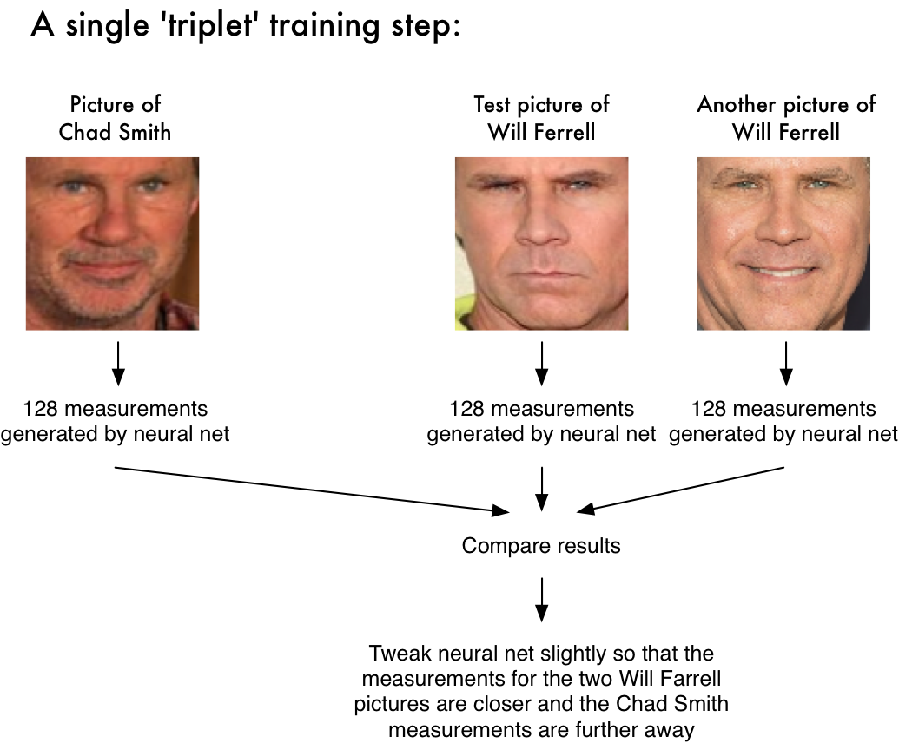

After repeating this step millions of times for millions of images of thousands of different people, the neural network learns to reliably generate 128 measurements for each person. Any ten different pictures of the same person should give roughly the same measurements.

Machine learning people call the 128 measurements of each face an **embedding.**

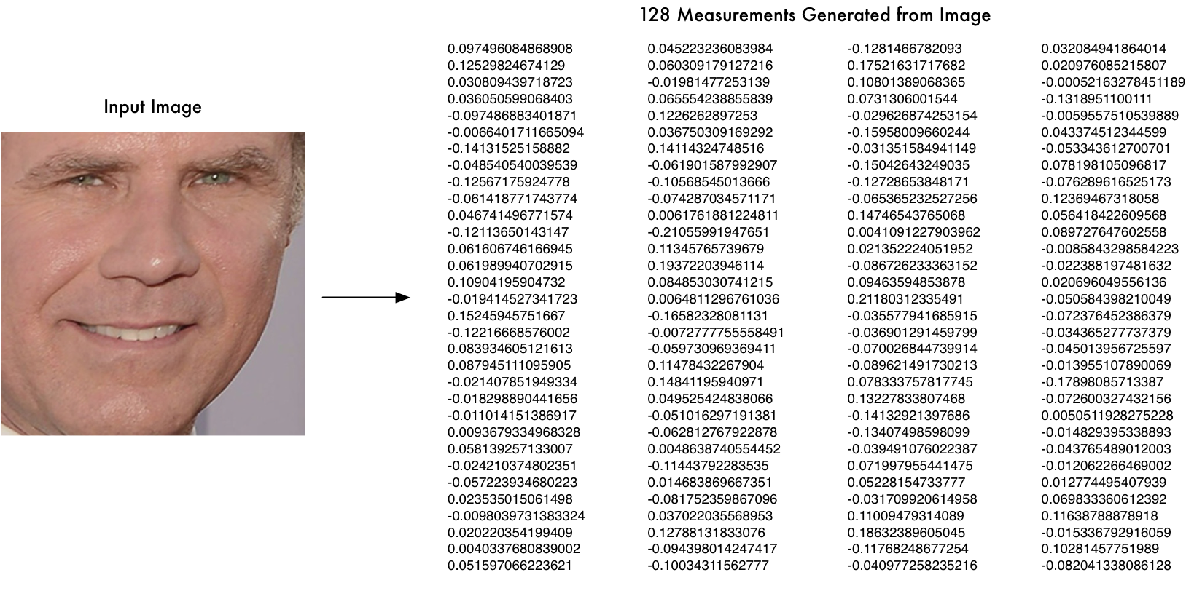

#### Step 4: Finding the person’s name from the encoding

* find the person in our database of known people who has the closest measurements to our test image.
* do that by using any basic machine learning classification algorithm.

#### Step 5: train the classifier:

train a classifier that can take in the measurements from a new test image and tells which known person is the closest match. Running this classifier takes milliseconds. The result of the classifier is the name of the person!

3.2.2 Top level data flow diagram (DFD)

* Context diagram



* Level 0

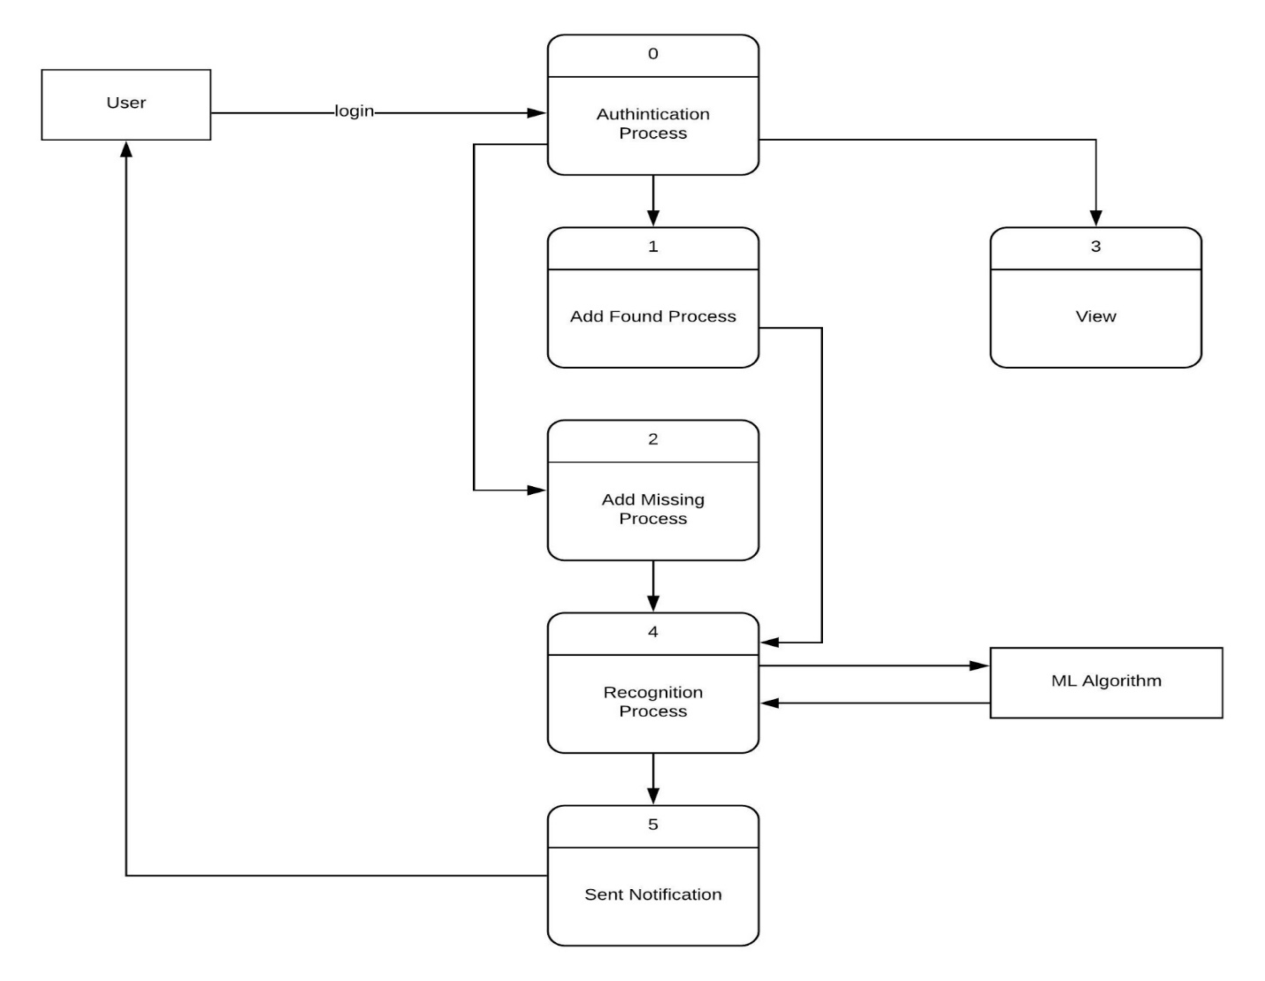

* Level 1

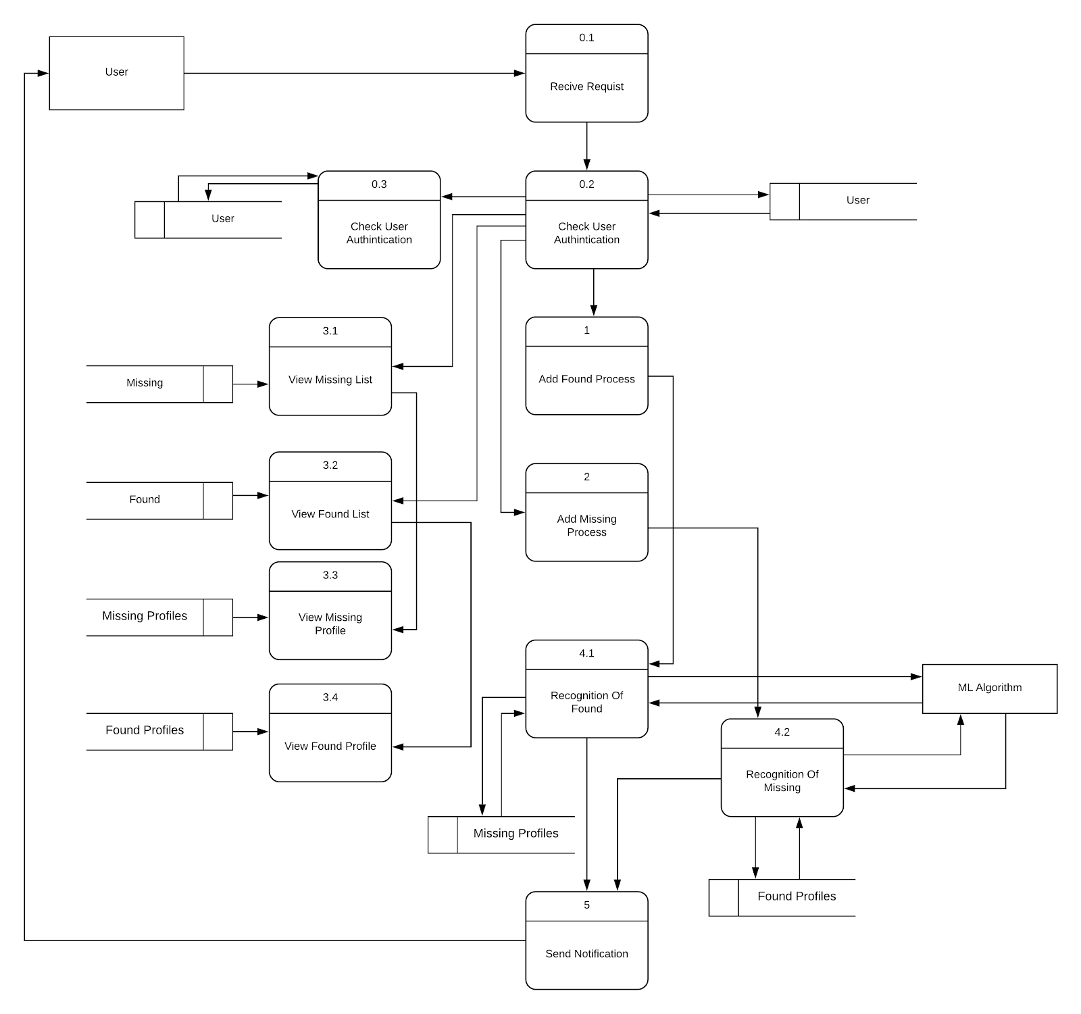

3.3 Design Rationale

In web application phase:

* We used 3-Tier architecture in to further enhance qualities like scalability as each tier is physically separated from the others thus it is easier to maintain each layer independently.
* It consists of several layers, so we can isolate and maintain errors in each layer and each layer has its own security, so the total security of the whole system is improved.
* It is better than “layered architecture “because layered doesn’t have physical separation which means scalability a hard issue and errors can’t be easily separated.

In face recognize phase:

* Using face landmark detectors Multi-task CNN instead of  Dlib face detector

One problem with the above approach seems to be that the Dlib face detector misses some of the hard examples (partial occlusion, silhouettes, etc). This makes the training set too "easy" which causes the model to perform worse on other benchmarks.

* used Labeled Faces in the Wild (LFW) dataset, our system achieves a new record accuracy of 99.63%.
* The benefit of our approach is much greater representational efficiency: we achieve state-of-the-art face recognition performance using only 128-bytes per face.
* the best results are achieved from traing by training the model using softmax loss.
* Using encoding and train a Deep Convolutional Neural Network, Researchers have discovered that the most accurate approach is to let the computer figure out the measurements to collect itself. Deep learning does a better job than humans at figuring out which parts of a face are important to measure.

**4. DATA DESIGN**

4.1 Data Dictionary

* Data dictionary describe database or collection of databases for FYM.

|  |  |  |  |  |  |
| --- | --- | --- | --- | --- | --- |
| Field name | Data type | Field size | Data format | Example | Description |
| FirstName | CharField | 40 |  |  |  |
| SecondName | CharField | 40 |  |  |  |
| Sex | CharField | 15 |  |  |  |
| DateOfBirth | CharField | 10 |  |  |  |
| AgeBeforeMissing | CharField | 3 |  |  |  |
| MissingDate/FoundDate | CharField | 10 |  |  |  |
| MissingFrom | CharField | 150 |  |  |  |
| HairColour | CharField | 50 |  |  |  |
| EyesColour | CharField | 50 |  |  |  |
| Weight | CharField | 4 |  |  |  |
| Height | CharField | 4 |  |  |  |
| RelatiiveID | CharField | 15 |  |  |  |
| RelativeRelation | CharField | 80 |  |  |  |
| Details | TextField |  |  |  |  |
| MissingPersonImage/FoundPersonImage | ImageField |  |  |  |  |
| FoundIn | CharField | 150 |  |  |  |
| Location | CharField | 150 |  |  |  |

**6. HUMAN INTERFACE DESIGN**

6.1 Overview of User Interface

The user will be able to use our system to complete all the expected features by:

1.Regester or Login

2.Add a missing person, add a found person, View missing list, View found list.

3.Contact Us

6.2 Screen Images

Home Page

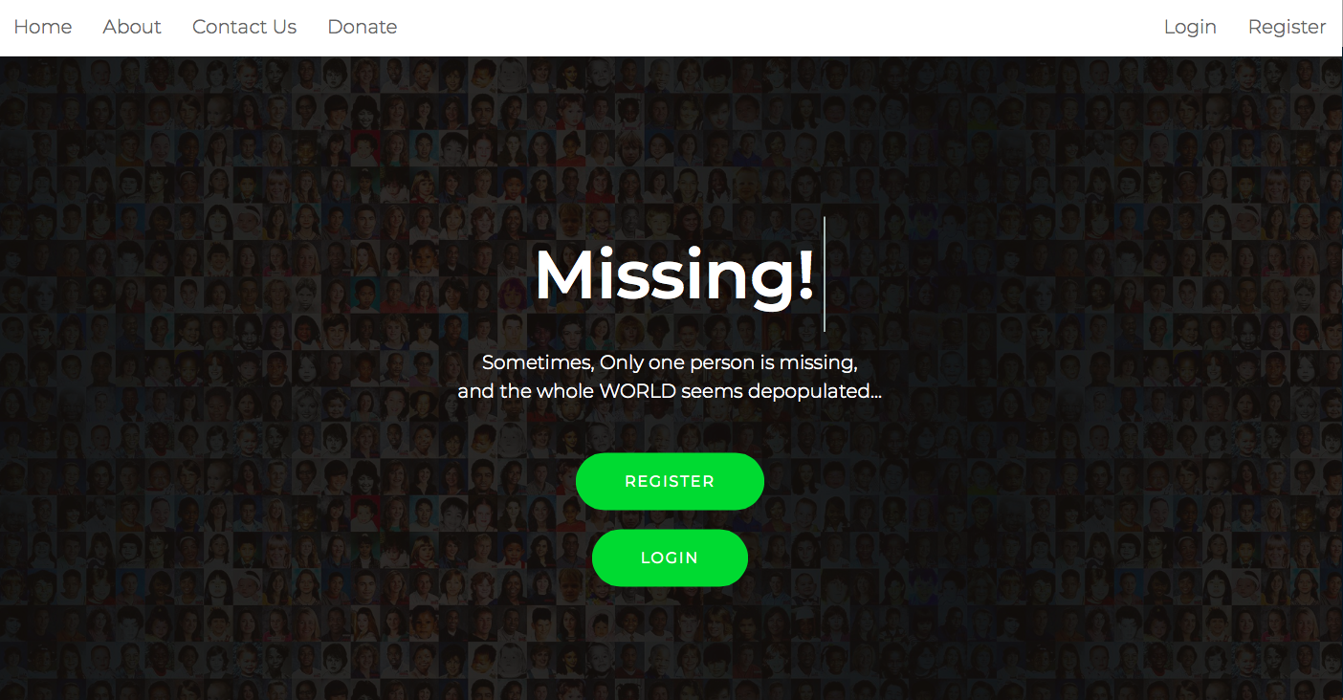

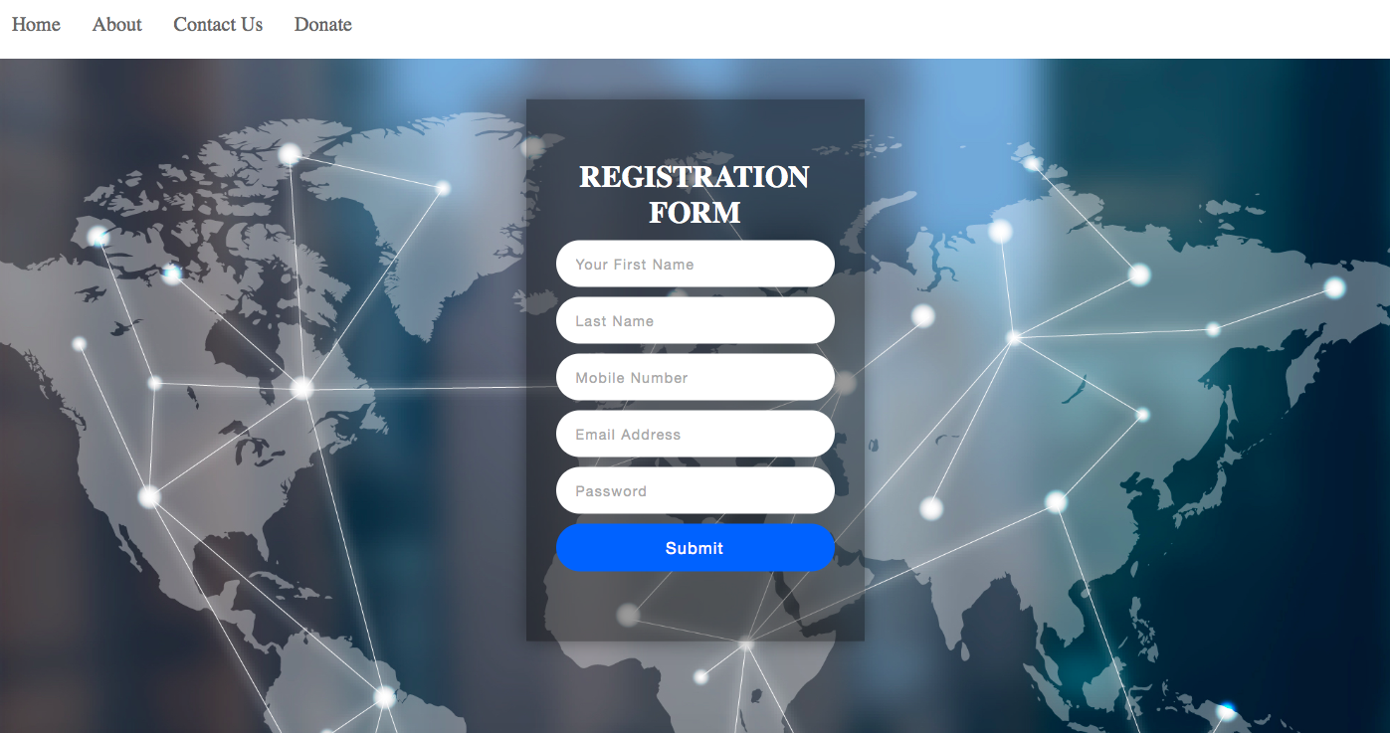

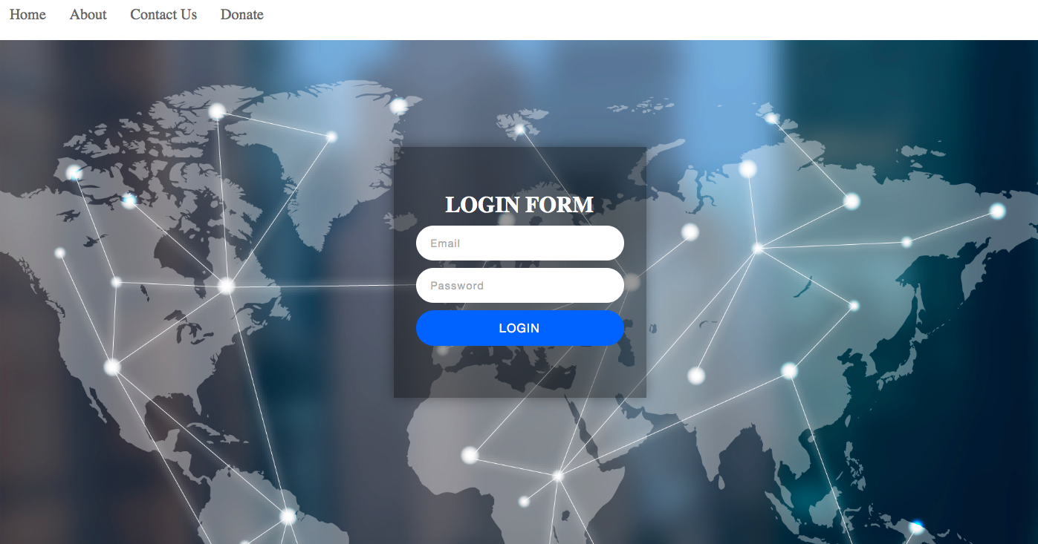

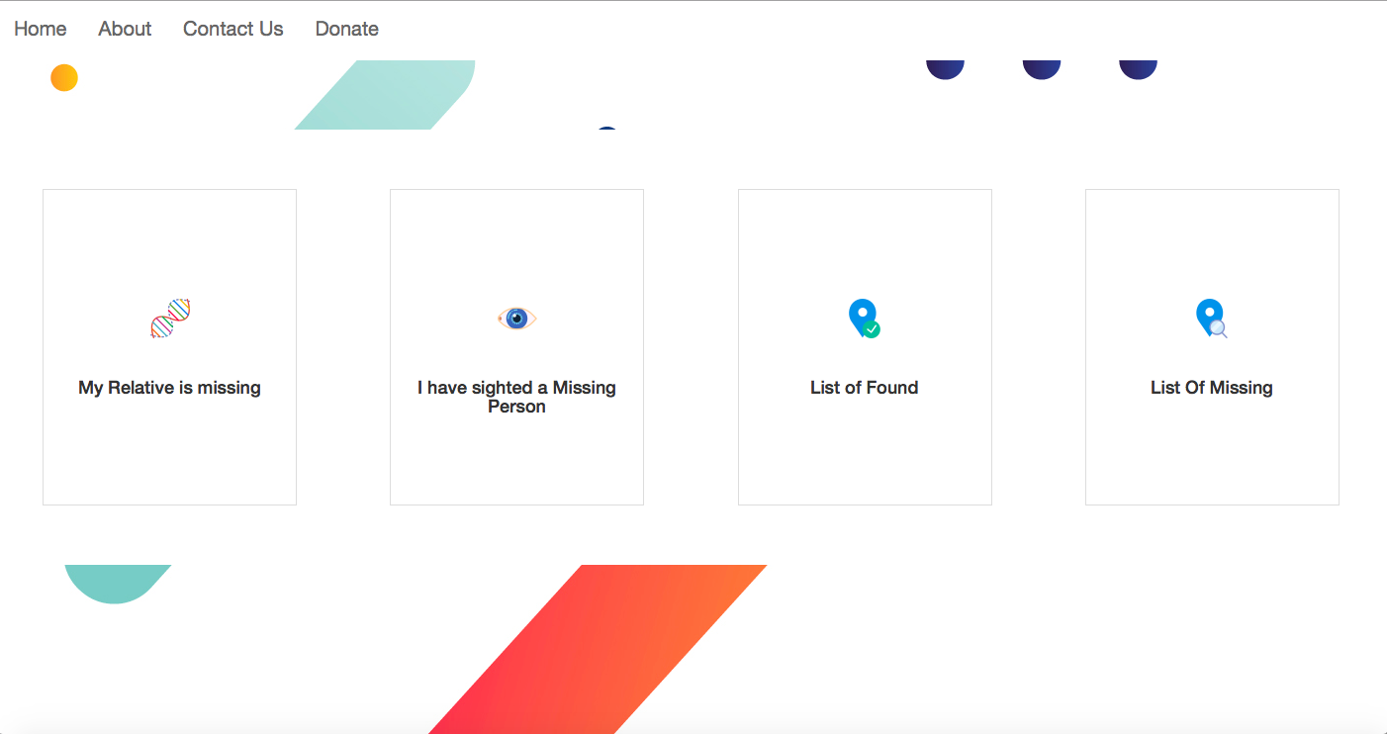





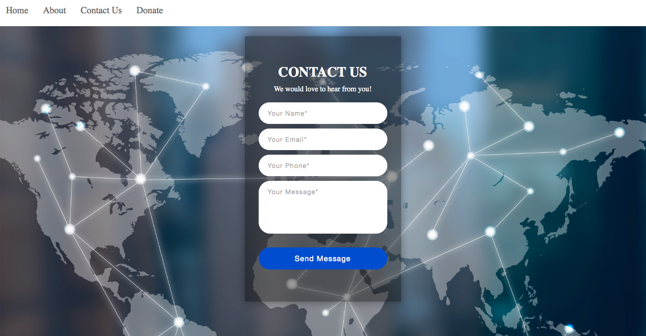

6.3 Screen Objects and Actions

A discussion of screen objects and actions associated with those objects.

**7. APPENDICES**

* This document is not intended to address installation and configuration details of the actual implementation for face recognize algorithm.
* As is true with any high-level design, this document will be updated and refine.
* The primary audiences of this document are the software developers in our team.